**SOFTWARE QUALITY ENGINEERING**

**Test Cases Result Report**

**Submitted By:**

Muhammad Memoon (20-SE-030)

Sabha Rani(20-SE-032)

Muhammad Huzaifa(20-SE-045)

**Submitted To:**

**Ma’am Farwa Aizaz**

HITEC UNIVERSITY, TAXI

**Test Cases Execution**

**Feature: Account creation**

|  |  |  |  |  |  |  |  |
| --- | --- | --- | --- | --- | --- | --- | --- |
| **Test Case ID** | **Test Case Name** | **Test Objective** | **Pre-conditions** | **Test Steps** | **Expected Result** | **Status** | **Actual Result** |
| **TC001** | Valid username and password | Verify if sign up is successful | None | 1. Enter a valid username and password. | Sign up should be successful. | Pass | Sign up successful |
| **TC002** | Username with special characters | Verify if sign up is successful | None | 1. Enter a username containing special characters. | Sign up should be successful. | Pass | Sign up successful |
| **TC003** | Short password | Validate the minimum password length | None | 1. Enter a username and a password less than 8 characters long. | Sign-up should fail, displaying an error message. | Fail | Sign-up failed - Password should be at least 8 characters long |
| **TC004** | Long password | Validate the maximum password length | None | 1. Enter a username and a password exceeding the maximum character limit. | Sign-up should fail, displaying an error message. | Fail | Sign-up failed - Password exceeds the maximum character limit |
| **TC005** | Duplicate username | Verify if sign up fails for duplicate username | A username that already exists in the system | 1. Enter a username that already exists in the system. | Sign-up should fail, displaying an error message. | Fail | Sign-up failed - Username already exists |

**Feature: Home Screen**

| **Test Case ID** | **Test Case Name** | **Test Objective** | **Pre-conditions** | **Test Steps** | **Expected Result** | **Status** | **Actual Result** |
| --- | --- | --- | --- | --- | --- | --- | --- |
| TC001 | Display home screen | Verify if the system displays a home screen with specified components | None | 1. Access the application and log in. | The home screen should be displayed with the following components: | Pass | Home screen displayed with customize a meal, most rated recipes, account activity, meal plan, and search bar |

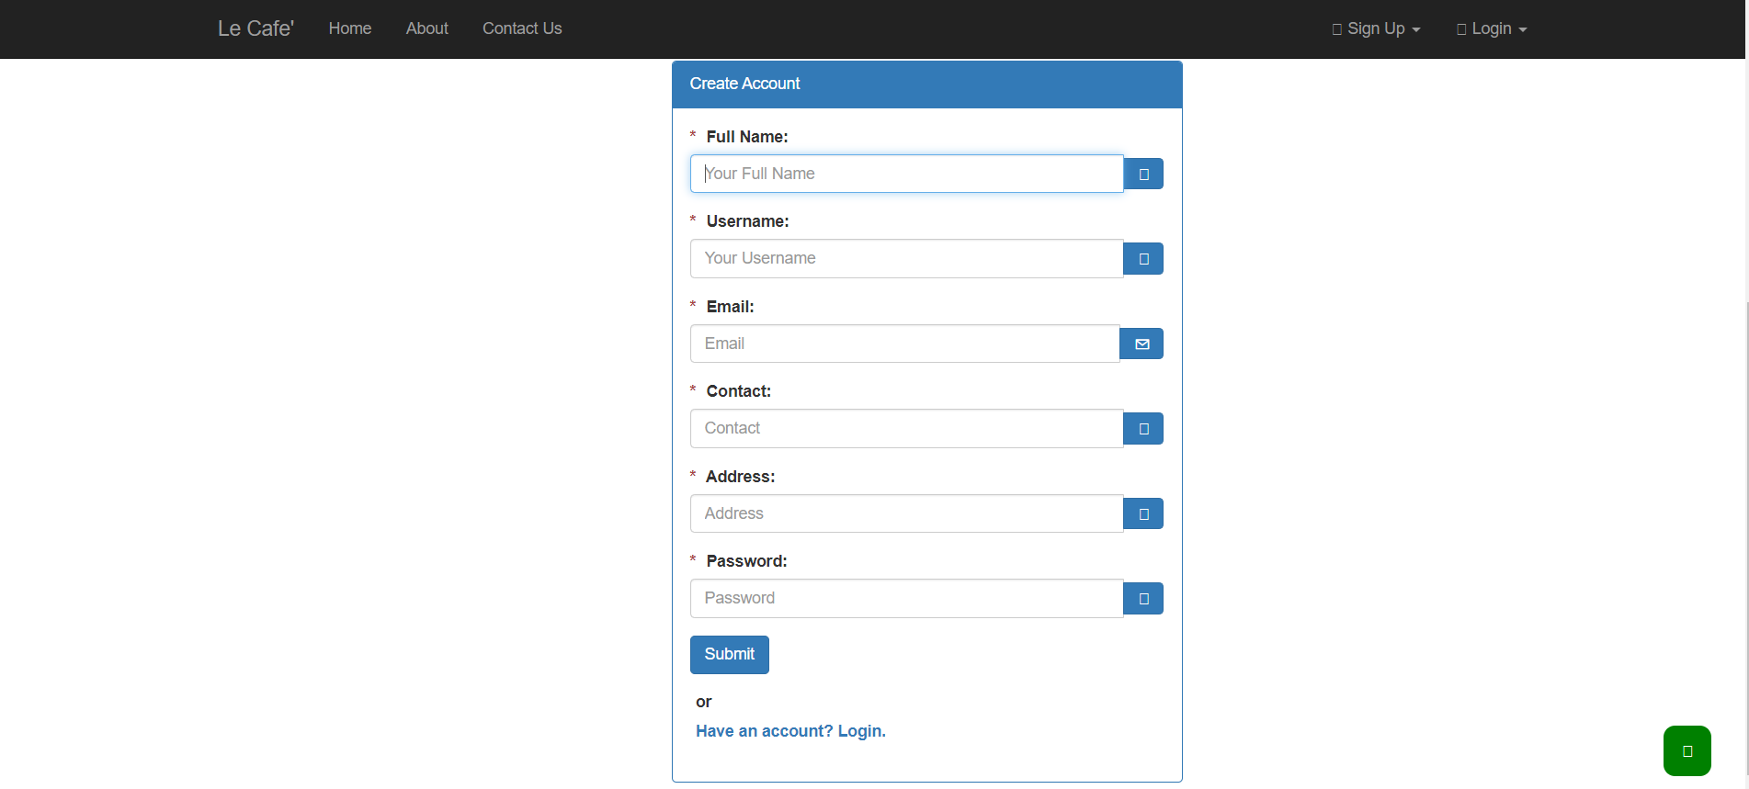

**Feature: Search Bar**

| **Test Case ID** | **Test Case Name** | **Test Objective** | **Pre-conditions** | **Test Steps** | **Expected Result** | **Result** | **Actual Result** |
| --- | --- | --- | --- | --- | --- | --- | --- |
| TC001 | Valid search query | Verify if the system returns relevant results for a valid search query | None | 1. Enter a valid search query in the search bar | The system should display relevant search results based on the query | Pass | Relevant search results displayed for the valid query |
| TC002 | Empty search query | Verify if the system provides appropriate empty feedback for an search query | None | 1. Leave the search bar empty and submit the search | The system should display a message indicating that a search query is required | Fail | No error message displayed for the empty search query |
| TC003 | Search query with no results | Verify if the system handles a search query with no matching results | None | 1. Enter a search query that does not match any available data | The system should display a message indicating that no results were found | Pass | No results found message displayed for the query |
| TC004 | Search with special characters | Verify if the system properly handles search queries with special characters | None | 1. Enter a search query containing special characters | The system should correctly process the search query and display relevant results | Pass | Relevant search results displayed for the special query |
| TC005 | Case sensitivity in search | Verify if the system performs case-insensitive searches | None | 1. Enter a search query with mixed case characters | The system should ignore case sensitivity and return results matching the query | Pass | Case-insensitive search performed correctly |
| TC006 | Auto-suggestions in search | Verify if the system provides auto-suggestions while typing in the search bar | None | 1. Enter a partial search query and observe the auto-suggestions displayed in the dropdown list | The system should display relevant auto-suggestions based on the entered search query | Pass | Relevant auto-suggestions displayed as expected |
| TC007 | Clear search query | Verify if the system allows clearing the search query | None | 1. Enter a search query and click on the clear button or icon within the search bar | The search bar should be cleared, and no search results should be displayed | Pass | Search bar cleared successfully |
| TC008 | Search history and recent searches | Verify if the system maintains a search history and recent searches | None | 1. Perform multiple searches and verify if the system stores the search history and recent search queries | The system should display a search history or recent searches for quick access | Pass | Search history and recent searches displayed correctly |

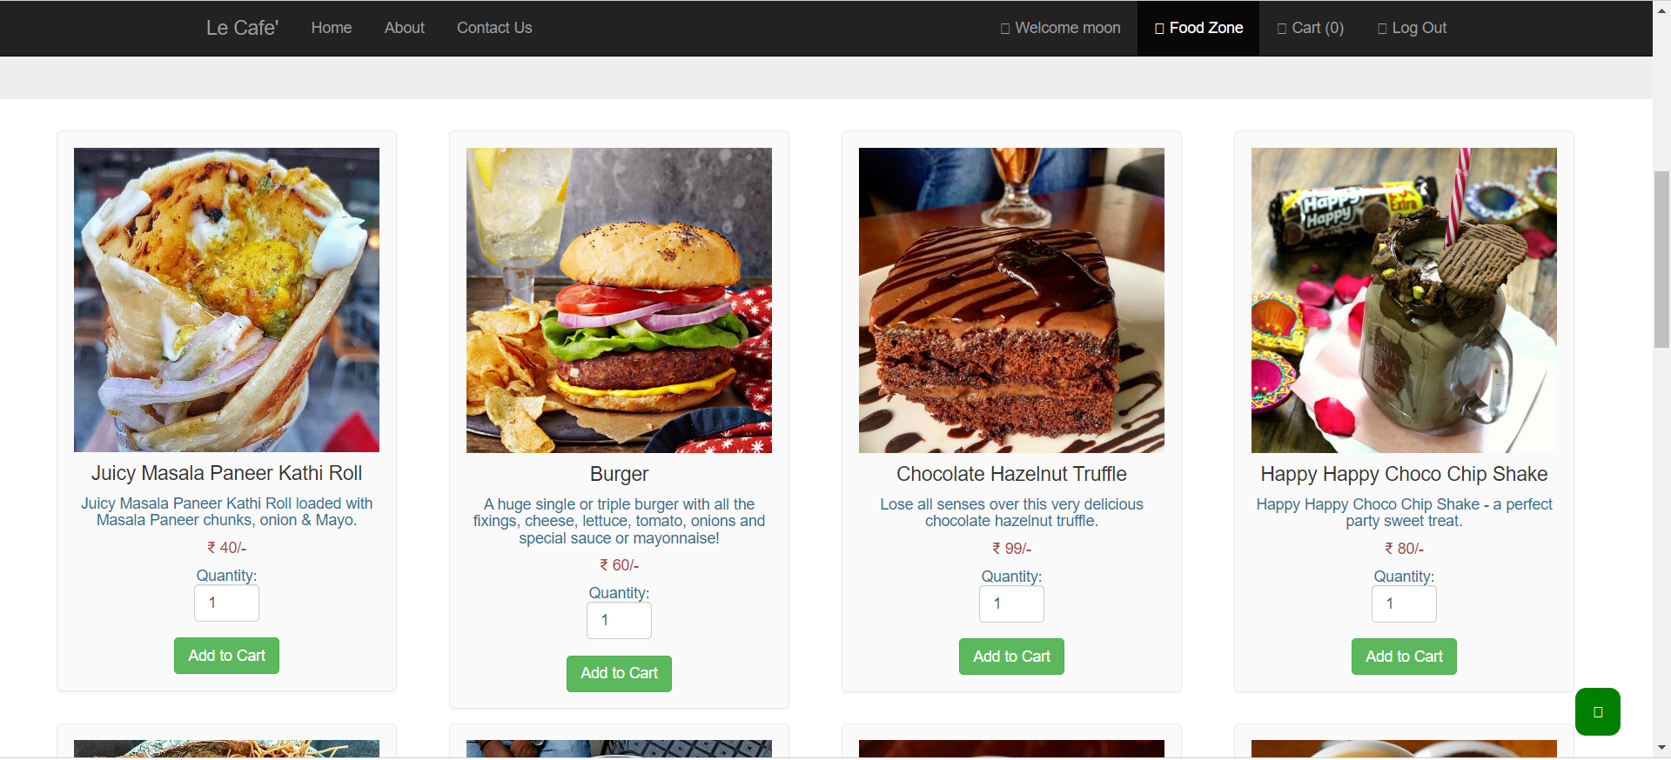

**Feature: Place Order**

| **Test Case ID** | **Test Case Name** | **Test Objective** | **Pre-conditions** | **Test Steps** | **Expected Result** | **Result** | **Actual Result** |
| --- | --- | --- | --- | --- | --- | --- | --- |
| TC001 | Confirm customer registration | Verify if the system confirms customer registration if already registered | None | 1. Check if the customer is already registered | The system should confirm customer registration and initiate the order placement process | Pass | Customer registered, order placement process initiated |
| TC002 | Register option for new customers | Verify if the system provides registration options for new customers | None | 1. Check if the customer is new or existing | New customers should receive registration options and can continue placing an order | Pass | New customer received registration options and can continue placing an order |
| TC003 | Select order type | Verify if the customer can specify whether the order is for pick-up or delivery | None | 1. Select the desired order type (pick-up or delivery) | The customer should be able to successfully select the order type | Pass | Customer selected order type successfully |
| TC004 | Provide delivery location | Verify if the customer can provide a valid delivery location (if applicable) | None | 1. Enter a valid delivery location (if the order is for delivery) | The customer should be able to provide a valid delivery location (if applicable) | Pass | Customer provided a valid delivery location |
| TC005 | Display menu for specified date | Verify if the system displays the menu for the specified date | None | 1. Specify a date and check if the menu is displayed for that date | The system should display the menu for the specified date | Pass | Menu for the specified date displayed |
| TC006 | Display available food items | Verify if the menu displays only available food items for the specified date | None | 1. Check if the menu displays only available food items for the specified date | The menu should display only available food items for that date | Pass | Menu displayed with only available food items |
| TC007 | Specify number of units | Verify if the customer can indicate the number of units for each menu item | None | 1. Select a menu item and specify the desired number of units | The customer should be able to specify the desired number of units for each menu item | Pass | Customer specified the desired number of units for each menu item |
| TC008 | Order multiple identical meals | Verify if the system permits ordering multiple identical meals | None | 1. Select a menu item and specify the desired number of units (more than 1) | The system should allow the customer to order multiple identical meals | Pass | Customer successfully ordered multiple identical meals |

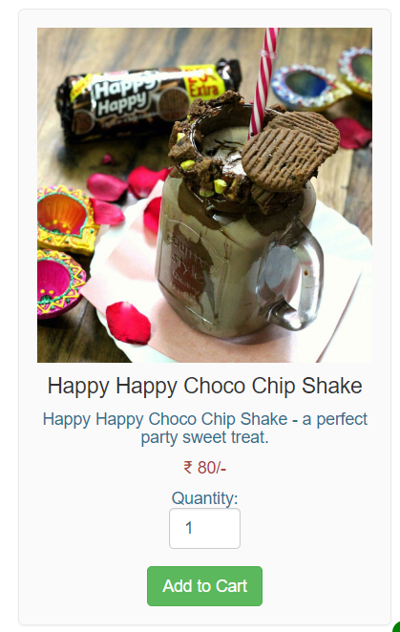

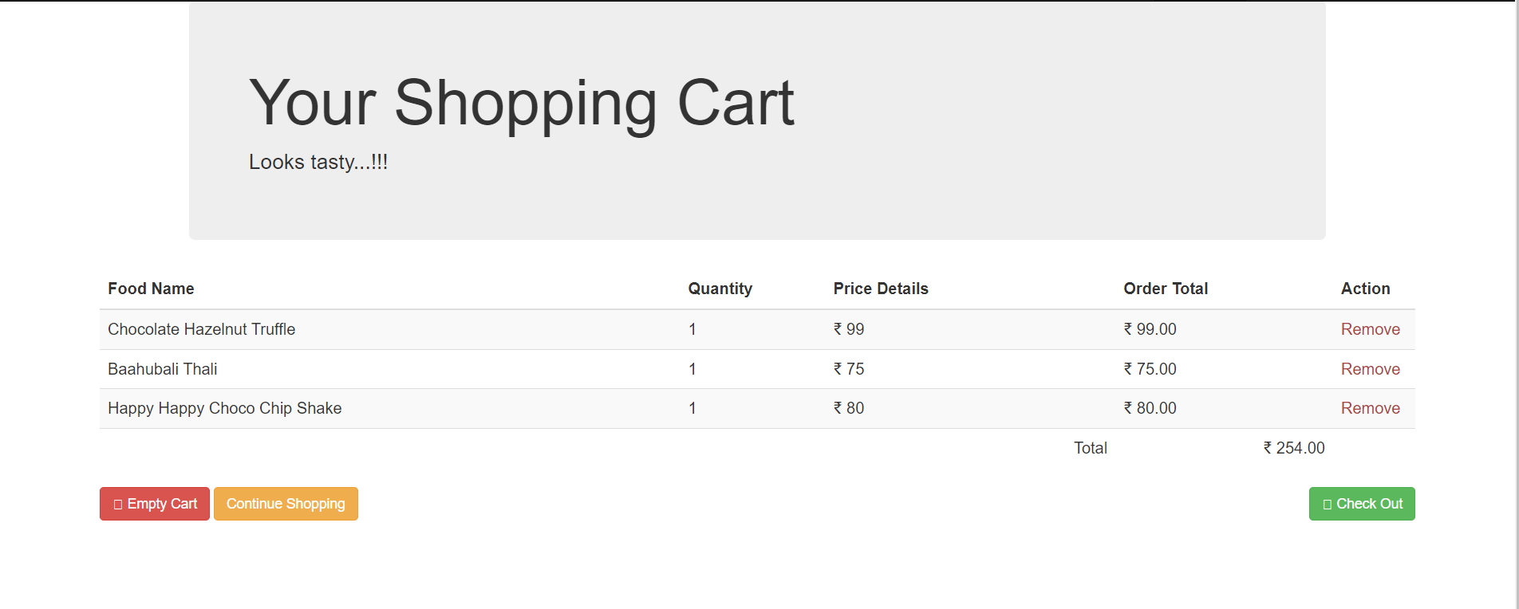

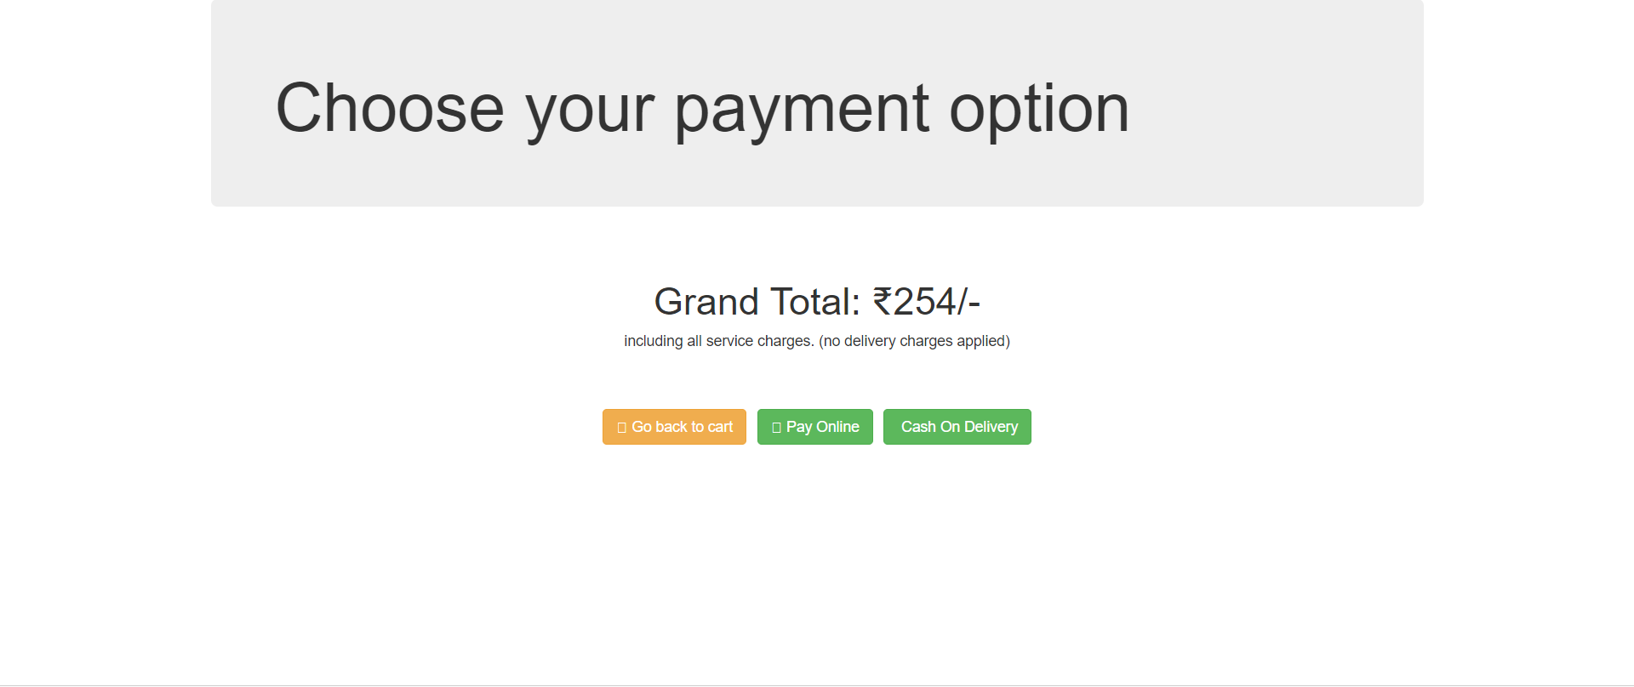

**Feature: Previous Orders**

| **Test Case ID** | **Test Case Name** | **Test Objective** | **Pre-conditions** | **Test Steps** | **Expected Result** | **Result** | **Actual Result** |
| --- | --- | --- | --- | --- | --- | --- | --- |
| TC001 | View previous orders | Verify if the customer can view previous meal orders | At least one order placed | 1. Access the customer's account | The customer should be able to view | Pass | Customer able to view previous meal orders |

**Feature: Payment Option**

| **Test Case ID** | **Test Case Name** | **Test Objective** | **Pre-conditions** | **Test Steps** | **Expected Result** | **Result** | **Actual Result** |
| --- | --- | --- | --- | --- | --- | --- | --- |
| TC001 | Select payment method | Verify if the system prompts the user to select a payment method | None | 1. Proceed to the payment section | The user should be prompted to select a payment method | Pass | User prompted to select a payment method |
| TC002 | Credit card payment option | Verify if the user can choose credit card payment for pick-up orders | Meal for pick-up | 1. Select the credit card payment option | The user should be able to successfully choose credit card payment | Pass | User successfully selected credit card payment option |
| TC003 | Cash payment option | Verify if the user can choose cash payment for pick-up orders | Meal for pick-up | 1. Select the cash payment option | The user should be able to successfully choose cash payment | Pass | User successfully selected cash payment option |

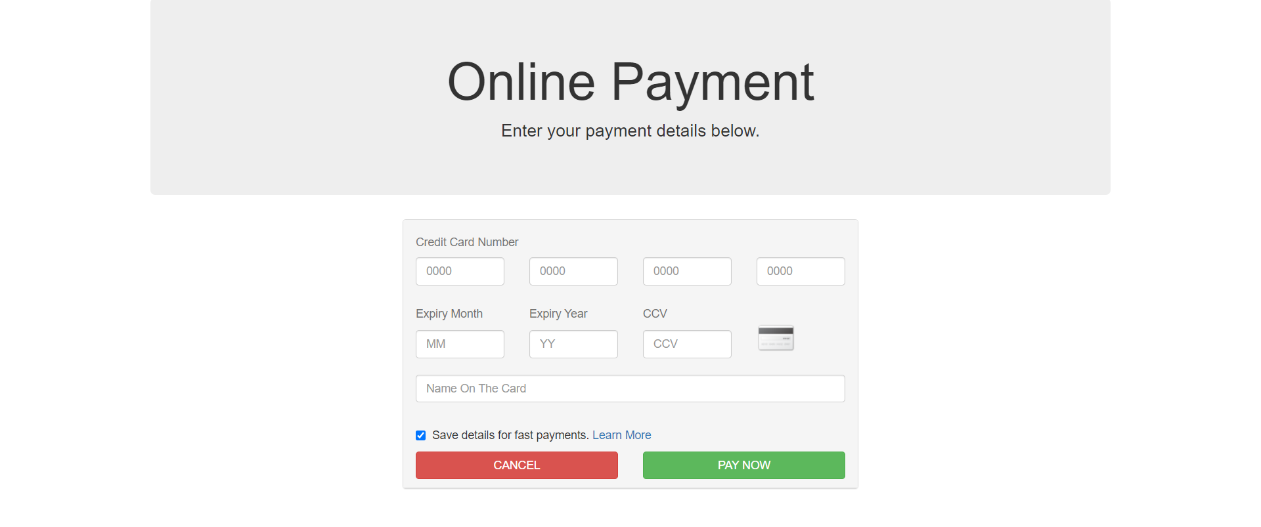

**Feature: Order Payment Deduct**

| **Test Case ID** | **Test Case Name** | **Test Objective** | **Pre-conditions** | **Test Steps** | **Expected Result** | **Result** | **Actual Result** |
| --- | --- | --- | --- | --- | --- | --- | --- |
| TC001 | Issue payment request | Verify if the system issues a payment request to the Bank system | None | 1. Confirm the order and select credit card payment | The system should successfully issue a payment request | Pass | Payment request successfully issued to the Bank system |

**Feature: Order Payment Confirm**

| **Test Case ID** | **Test Case Name** | **Test Objective** | **Pre-conditions** | **Test Steps** | **Expected Result** | **Result** | **Actual Result** |
| --- | --- | --- | --- | --- | --- | --- | --- |
| TC001 | Confirm payment acceptance | Verify if the system displays a confirmation message with the transaction number | None | 1. Accept the payment request and complete the transaction | The system should display a confirmation message with the transaction number | Pass | Payment acceptance confirmed with transaction number |

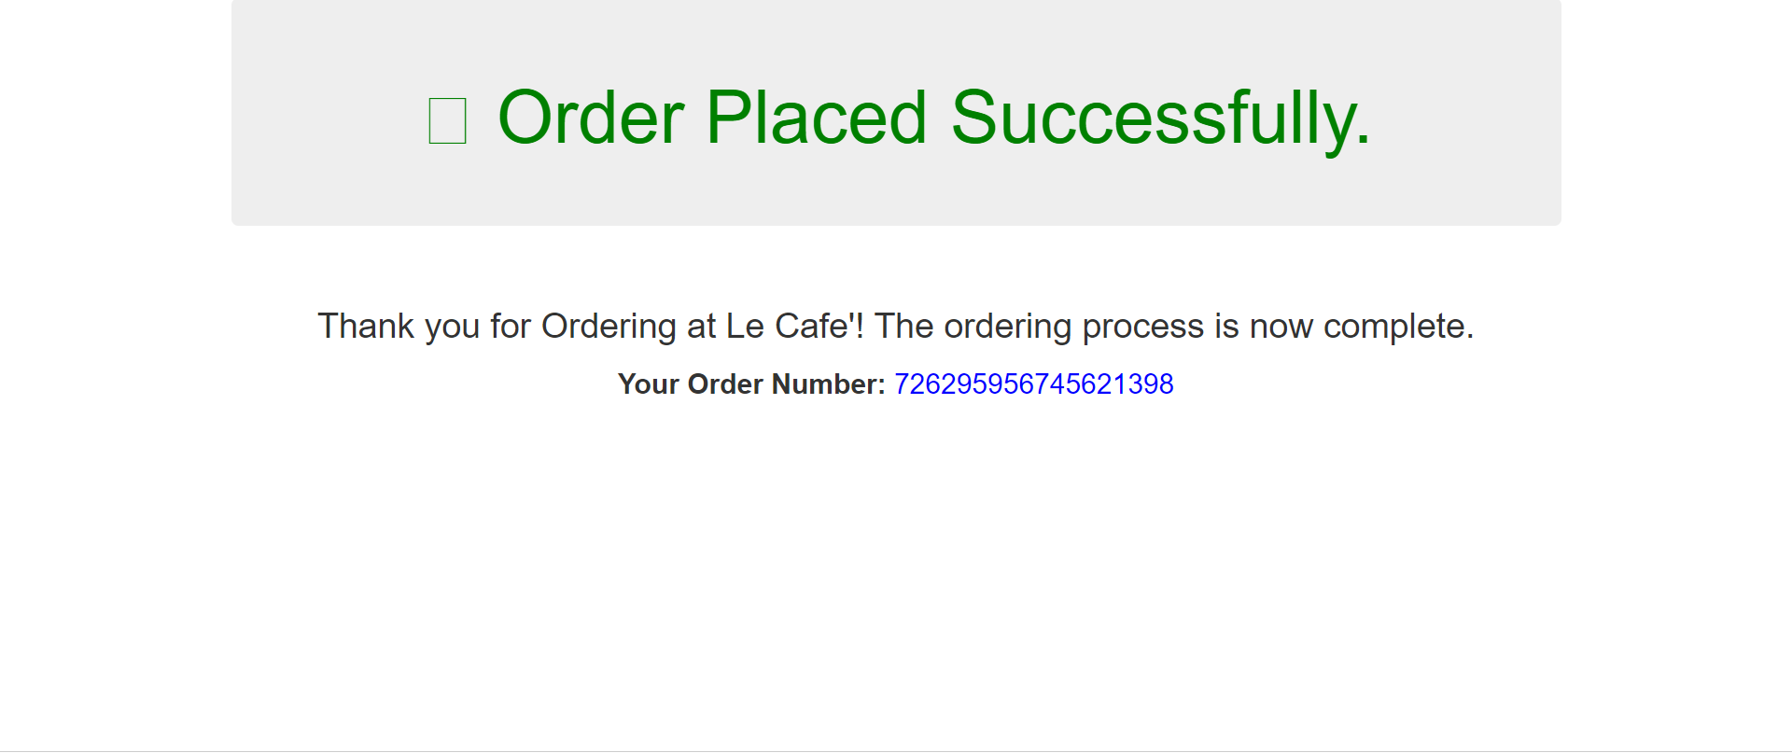

**Feature: Update Menu and Inventory**

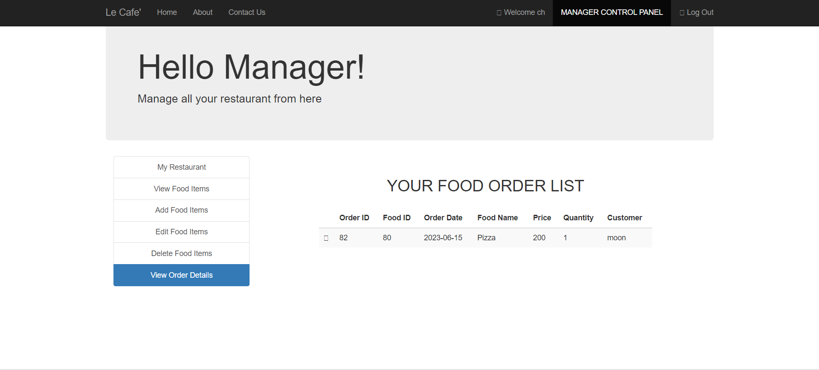

| **Test Case ID** | **Test Case Name** | **Test Objective** | **Pre-conditions** | **Test Steps** | **Expected Result** | **Result** | **Actual Result** |
| --- | --- | --- | --- | --- | --- | --- | --- |
| TC001 | Update menu and inventory | Verify if the system updates the menu to reflect items out of stock | None | 1. Check the cafeteria inventory and identify items that are now out of stock | The system should update the menu for the current order's date accordingly | Pass | Menu and inventory successfully updated |

**Feature: Create Menu**

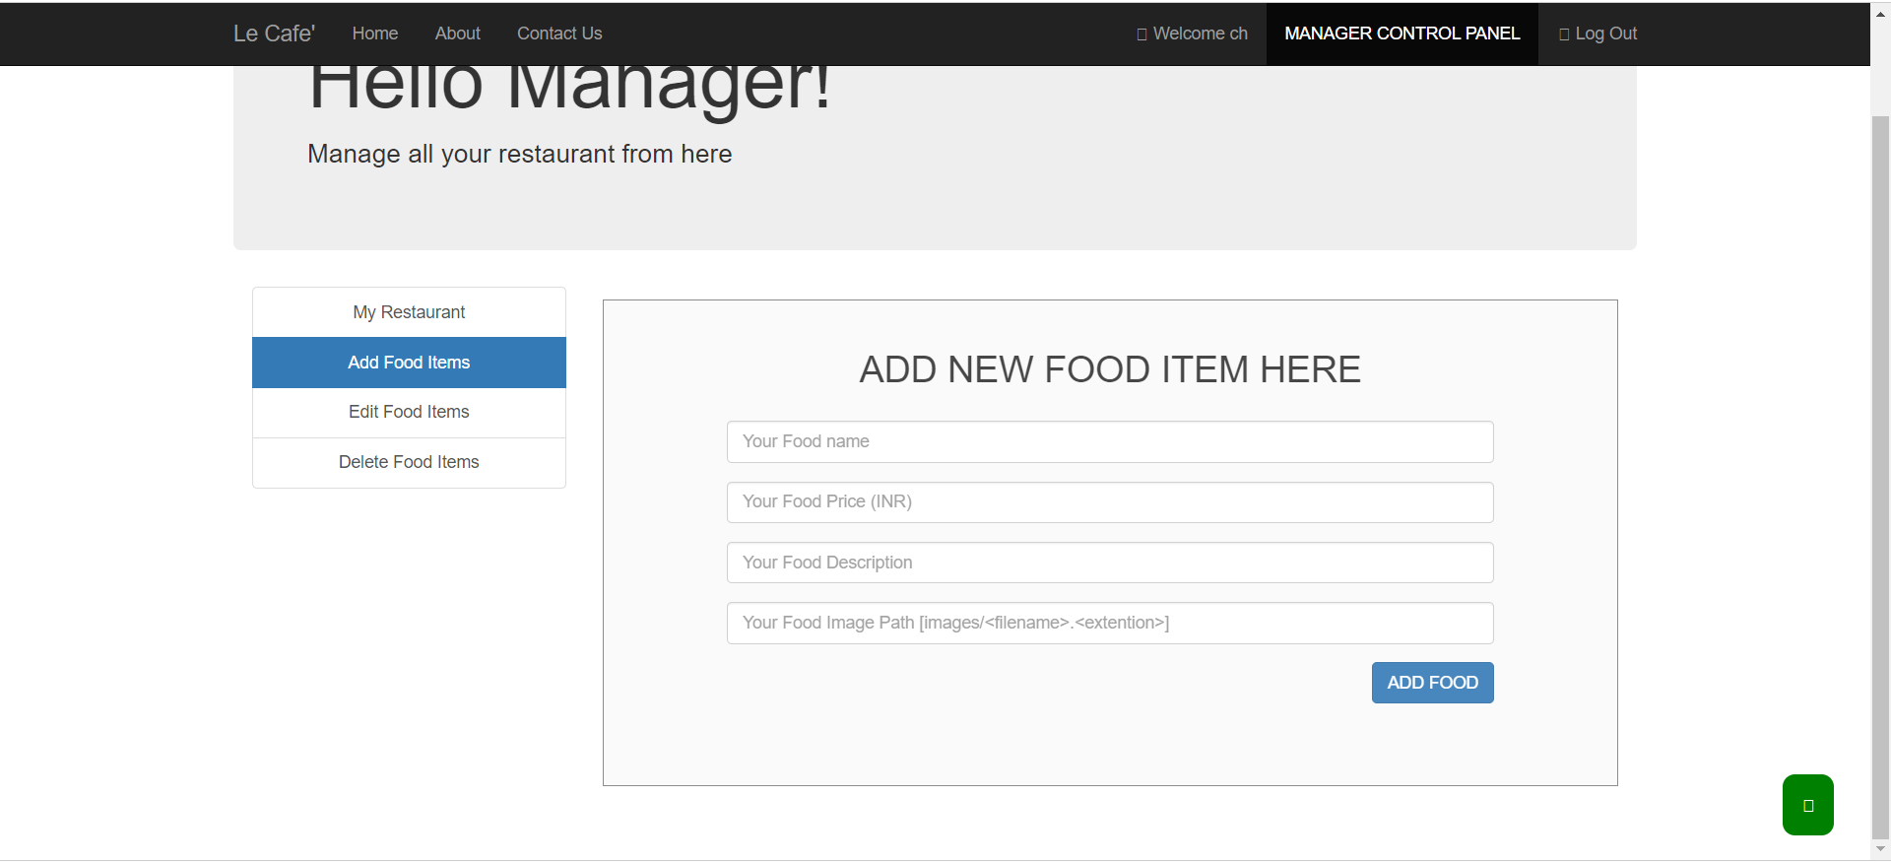

| **Test Case ID** | **Test Case Name** | **Test Objective** | **Pre-conditions** | **Test Steps** | **Expected Result** | **Result** | **Actual Result** |
| --- | --- | --- | --- | --- | --- | --- | --- |
| TC001 | Create menu option | Verify if the system provides an option for the manager to create a menu | None | 1. Access the manager's interface | The system should provide an option to create a menu | Pass | Create menu option available |
| TC002 | Add menu details | Verify if the manager can add menu details while creating the menu | None | 1. Select the create menu option | The manager should be able to successfully add menu details | Pass | Menu details added successfully |

**Feature: Modify Menu**

| **Test Case ID** | **Test Case Name** | **Test Objective** | **Pre-conditions** | **Test Steps** | **Expected Result** | **Result** | **Actual Result** |
| --- | --- | --- | --- | --- | --- | --- | --- |
| TC001 | Modify menu option | Verify if the system provides an option to modify an existing menu | None | 1. Access the manager's interface | The system should provide an option to modify an existing menu | Pass | Modify menu option available |
| TC002 | Update menu details | Verify if the manager can update the menu details | None | 1. Select the modify menu option | The manager should be able to successfully update the menu details | Pass | Menu details updated successfully |

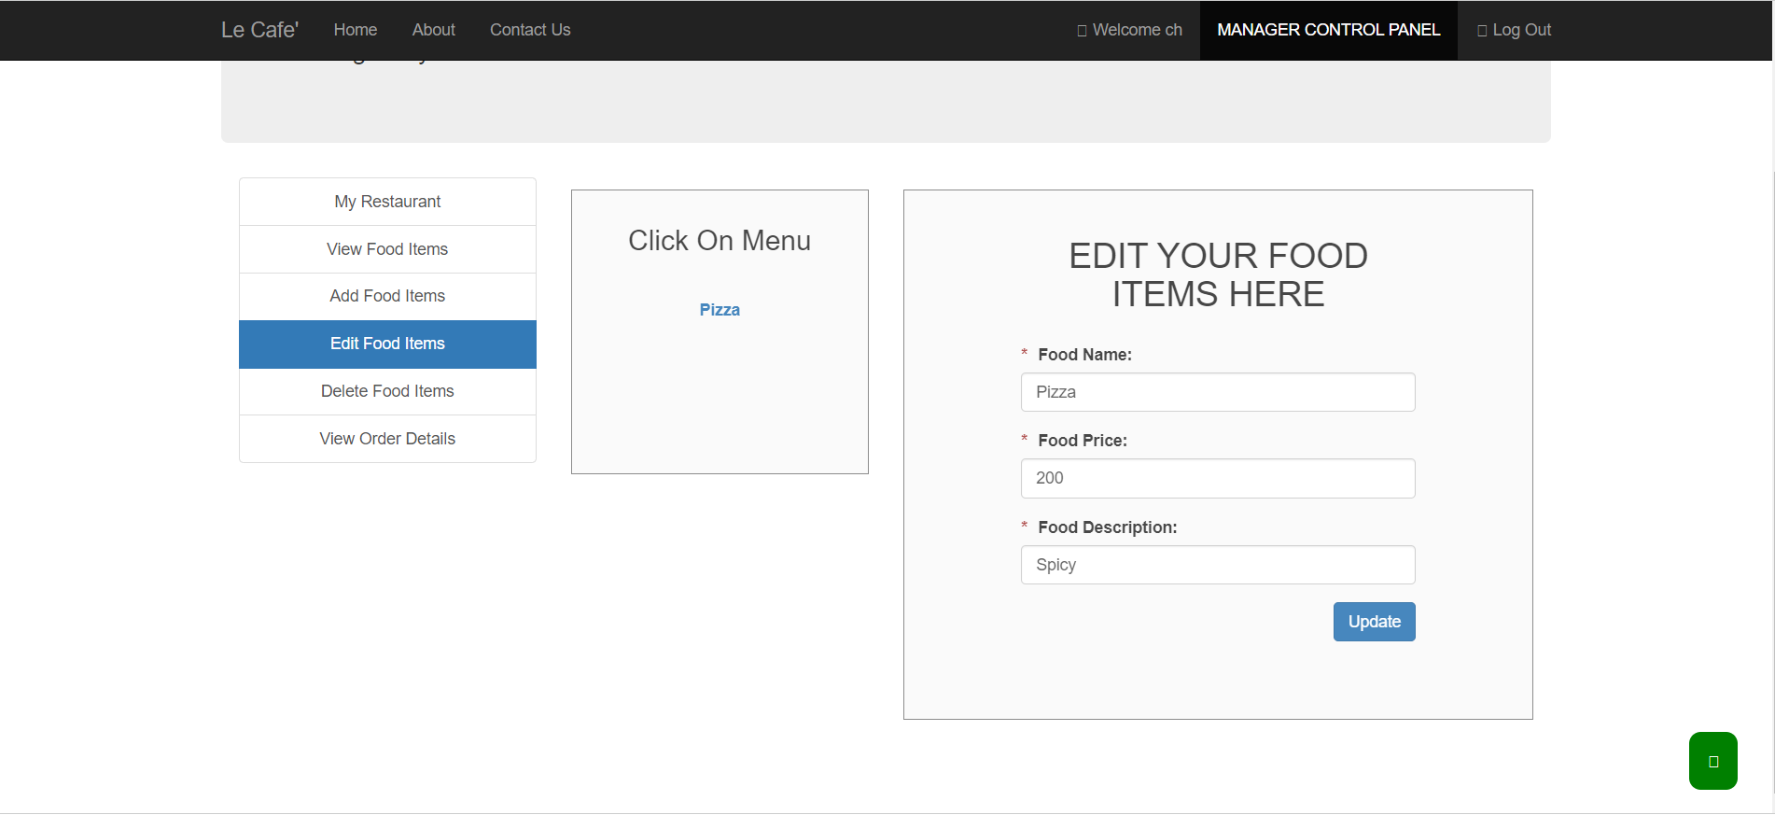

**Feature: Delete Menu**

| **Test Case ID** | **Test Case Name** | **Test Objective** | **Pre-conditions** | **Test Steps** | **Expected Result** | **Result** | **Actual Result** |
| --- | --- | --- | --- | --- | --- | --- | --- |
| TC001 | Delete menu option | Verify if the system provides an option to delete an existing menu | None | 1. Access the manager's interface | The system should provide an option to delete an existing menu | Pass | Delete menu option available |
| TC002 | Confirm menu deletion | Verify if the manager can confirm the deletion of the menu | None | 1. Select the delete menu option | The manager should be able to successfully confirm the deletion of the menu | Pass | Menu deletion confirmed successfully |

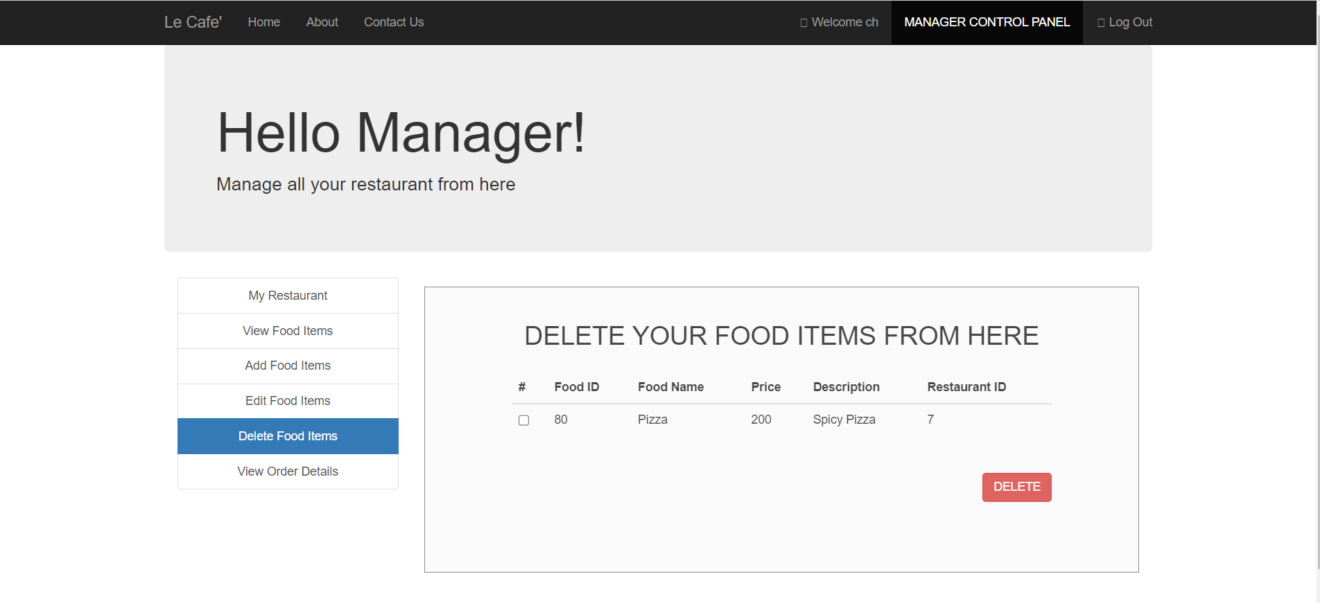

**Feature: Menu View**

| **Test Case ID** | **Test Case Name** | **Test Objective** | **Pre-conditions** | **Test Steps** | **Expected Result** | **Result** | **Actual Result** |
| --- | --- | --- | --- | --- | --- | --- | --- |
| TC001 | View modified menu | Verify if the user can view the modified menu after updating it | None | 1. Access the application | The user should be able to view the modified menu successfully | Pass | Modified menu displayed successfully |

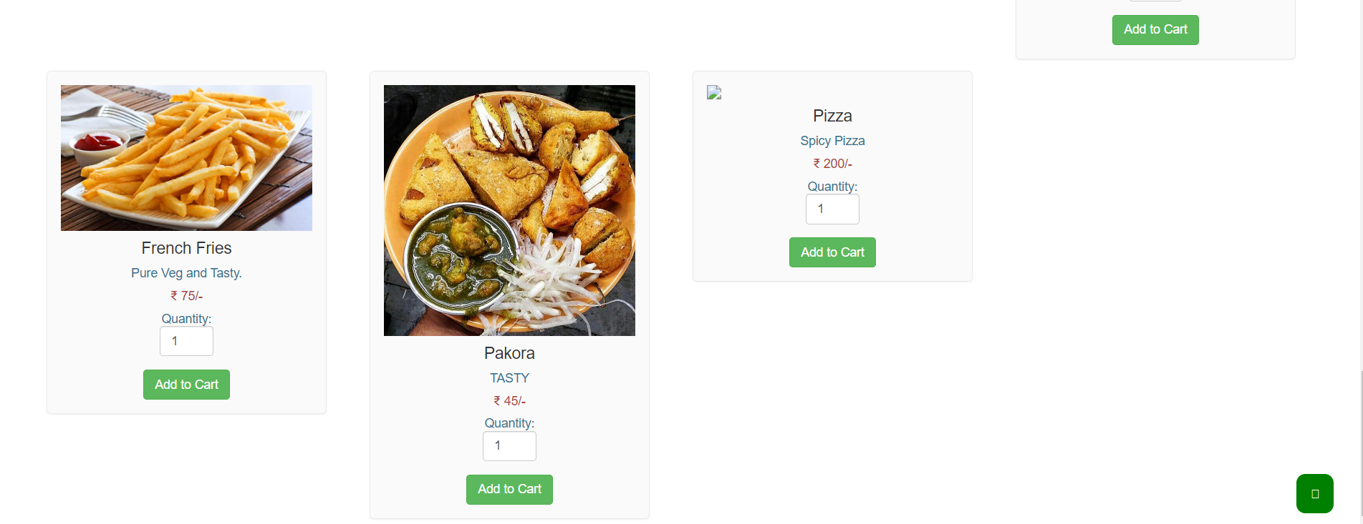

**Feature: Display all orders**

| **Test Case ID** | **Test Case Name** | **Test Objective** | **Pre-conditions** | **Test Steps** | **Expected Result** | **Result** | **Actual Result** |
| --- | --- | --- | --- | --- | --- | --- | --- |
| TC001 | Display all orders | Verify if the system displays all the orders to the chef | None | 1. Access the chef's interface | The system should display all the orders to the chef | Pass | All orders are displayed to the chef |

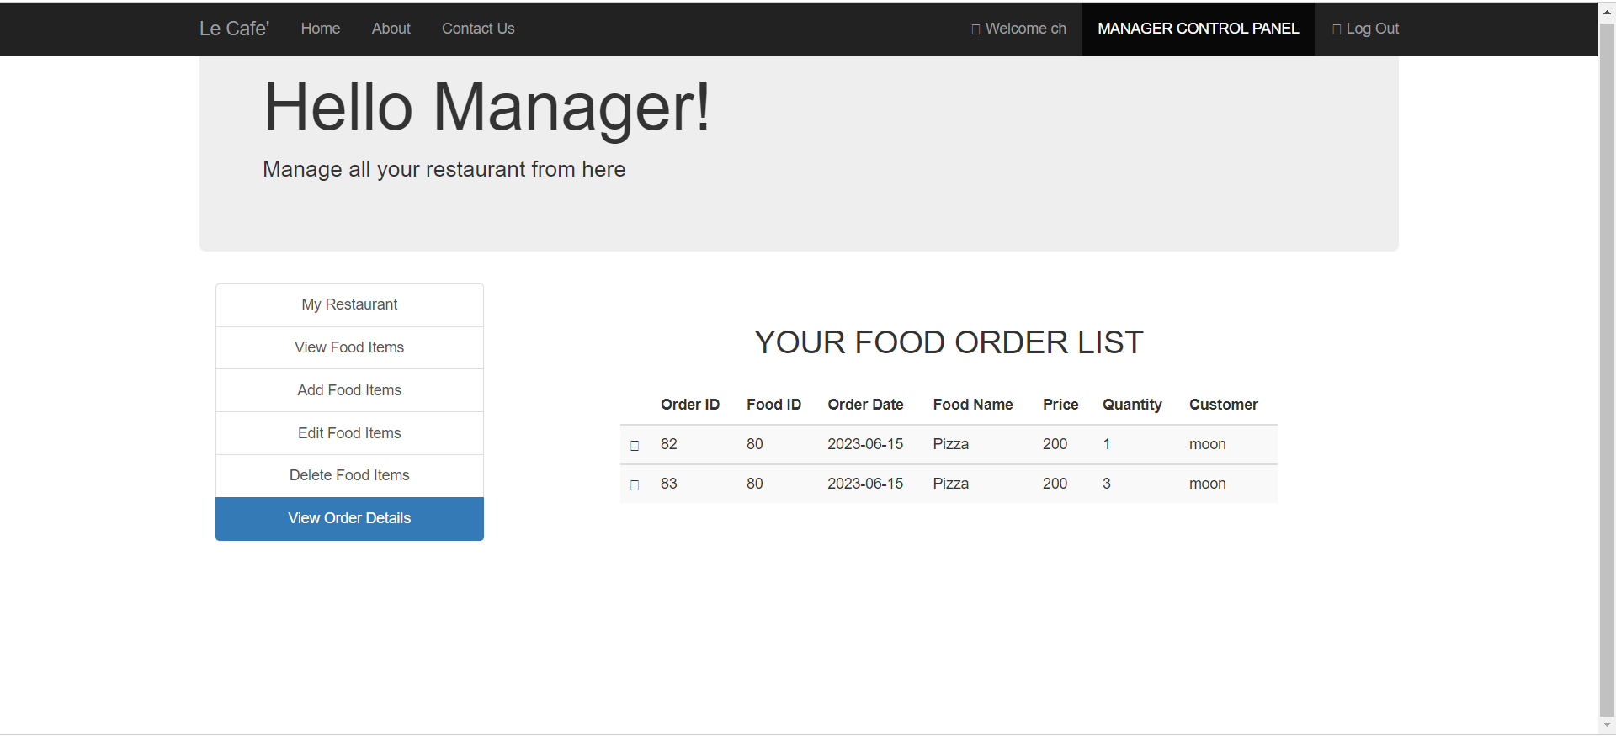

**Feature: Feedback Submission**

| **Test Case ID** | **Test Case Name** | **Test Objective** | **Pre-conditions** | **Test Steps** | **Expected Result** | **Result** | **Actual Result** |
| --- | --- | --- | --- | --- | --- | --- | --- |
| TC001 | Submit feedback | Verify if the registered user can submit feedback on the app | None | 1. Access the feedback submission feature | The feedback should be successfully submitted by the registered user | Pass | Feedback successfully submitted by the registered user |
| TC002 | Include detailed explanation | Verify if the feedback allows the user to provide a detailed explanation | None | 1. Fill in the feedback form with a detailed explanation | The submitted feedback should include the detailed explanation provided | Pass | Detailed explanation included in the submitted feedback |

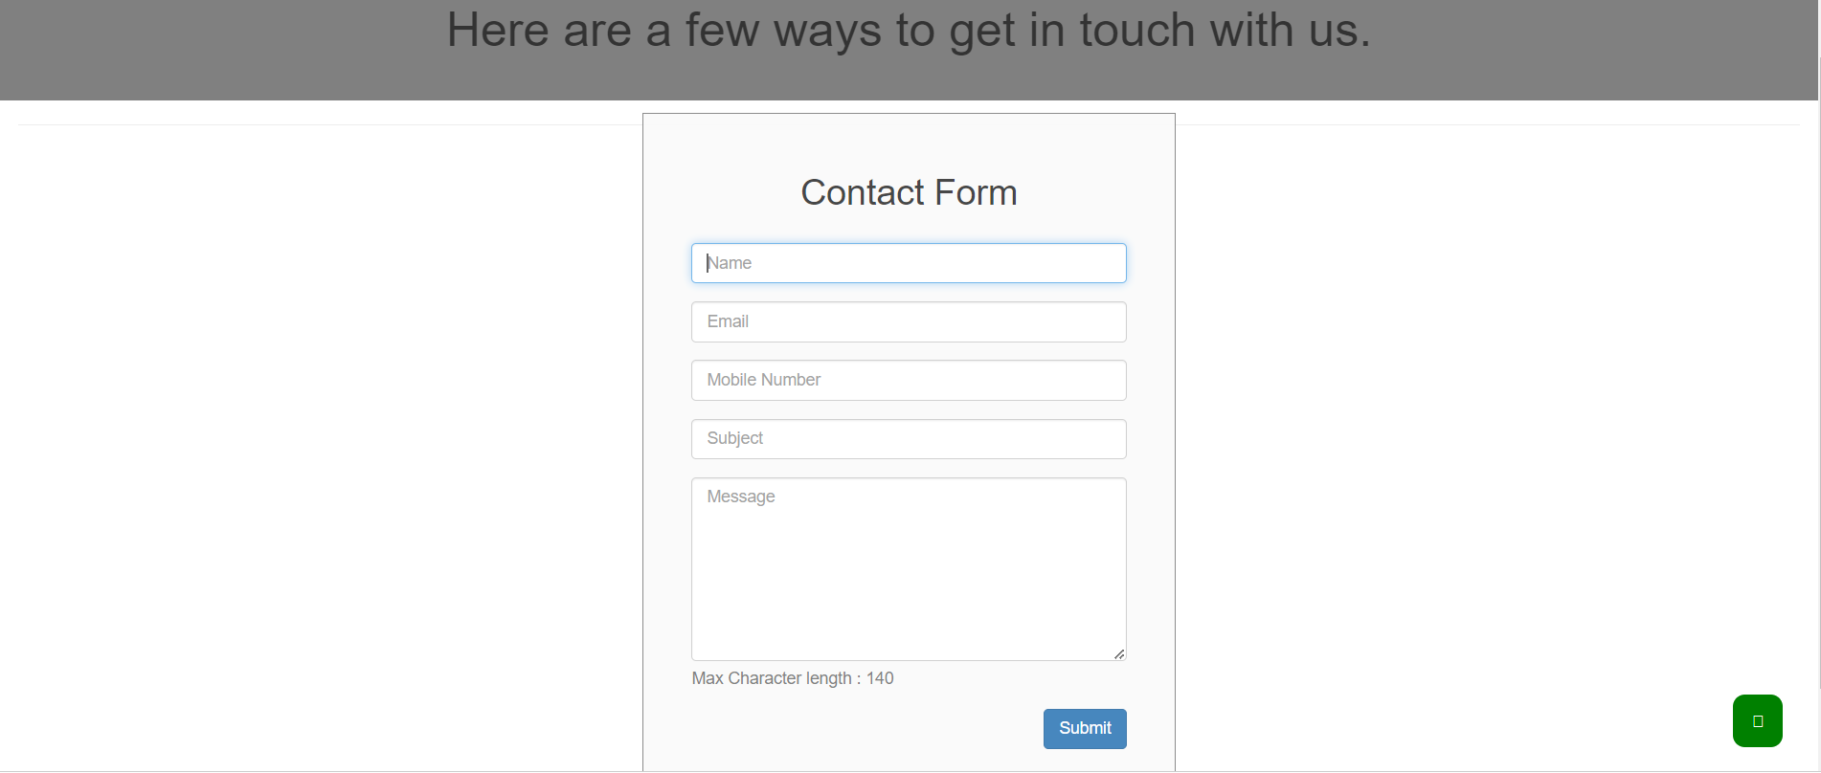

**Feature: Display Feedback to Admin**

| **Test Case ID** | **Test Case Name** | **Test Objective** | **Pre-conditions** | **Test Steps** | **Expected Result** | **Result** | **Actual Result** |
| --- | --- | --- | --- | --- | --- | --- | --- |
| TC001 | Display submitted feedback | Verify if the admin can view the submitted feedback | None | 1. Access the admin interface | The admin should be able to view the submitted feedback | Pass | Admin can view the submitted feedback |
| TC002 | Differentiate open and closed feedback | Verify if the admin can differentiate between open and closed feedback | None | 1. Check the feedback status | The admin should be able to identify whether a feedback is open or closed | Pass | Open and closed feedback is properly differentiated |